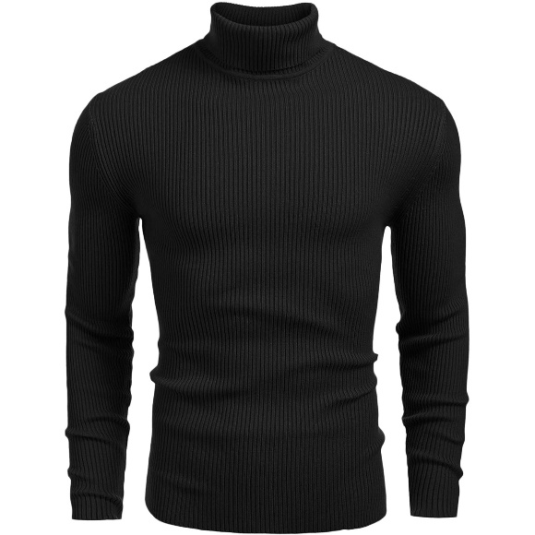

Men Slim Fit Lightweight Long Sleeve Turtleneck-Highneck Sweatshirt

Product details of Men Slim Fit Lightweight Long Sleeve Turtleneck-Highneck Sweatshirt

* Factory Premium Men Range for Winters
* Men’s Pullover Sweater Selling Points: Sexy Turtleneck Design, Stretch Slim Fit Pullover Shirt, Long Sleeve Casual Sweater, Lightweight Thermal Basic T Shirt
* Slim Fit. This fashion basic thermal turtleneck sweaters could be matched with stylish jeans or casual pants for the daily look, or pair with a suit or jacket for a classic style
* Great for fall and winter days, suits for daily, business, work, party, semi-formal or any other casual occasions
* Made In Pakistan
* Factory Premium Men Range for Winters
* Men’s Pullover Sweater Selling Points: Sexy Turtleneck Design, Stretch Slim Fit Pullover Shirt, Long Sleeve Casual Sweater, Lightweight Thermal Basic T Shirt
* Slim Fit. This fashion basic thermal turtleneck sweaters could be matched with stylish jeans or casual pants for the daily look, or pair with a suit or jacket for a classic style
* Great for fall and winter days, suits for daily, business, work, party, semi-formal or any other casual occasions
* Made In Pakistan

Specifications of Men Slim Fit Lightweight Long Sleeve Turtleneck-Highneck Sweatshirt